**Coolest cDAQ demo ever! I promise... ;)**

**What is it?**

Just a cool cDAQ User Interface demo. With this demo you can configure your measurements with cool UI. The configuration part can detect current system even if you add/remove modules during runtime. The UI will change according to current system. Which is pretty cool (specially with real HW). Also the measurement part has a cool UI (iPAD look and “touch screen like” scrolling effect).

**Why I made this demo?**

With LabVIEW it’s pretty easy to build something like this. So this is just an example how to create cool UI with LabVIEW.

**How to demo?**

There are multiple ways to demo this SW but I like to do it this way.

1. **Open MAX**

Make sure you don’t have cDAQ devices or any other device on MAX under Devices and Interfaces:

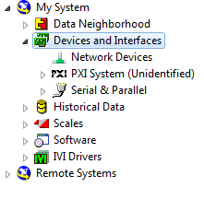

1. **Launch “cDAQ - UI - Main.vi”**

It should launch and you will see this screen:

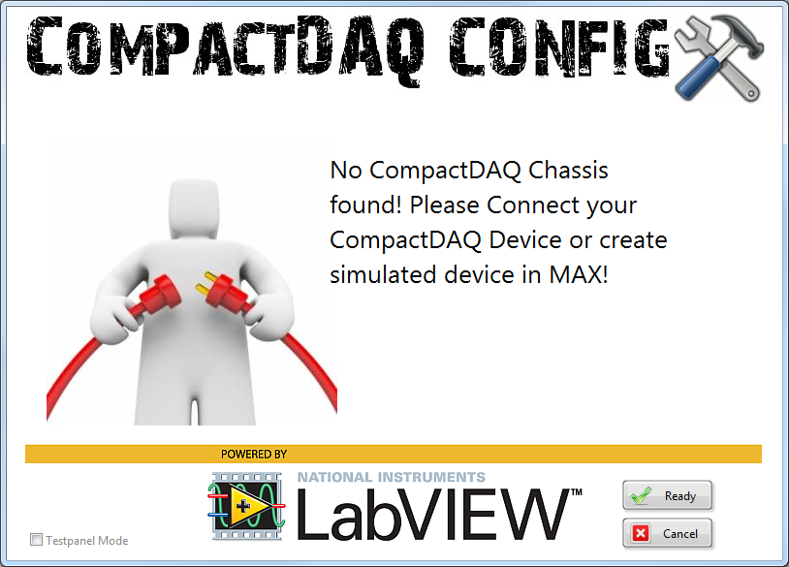

1. **Create simulated NI 9178 Chassis with MAX**

Goto MAX (resize and move it to next to the LV screen) and create new simulated NI 9178 chassis:

First select “**Create New…**”

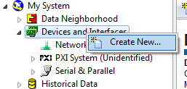

Then select “Simulated **NI-DAQmx Device or Modular Instrument**”

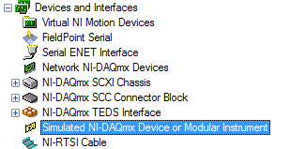

And Select “**NI cDAQ-9178**”:

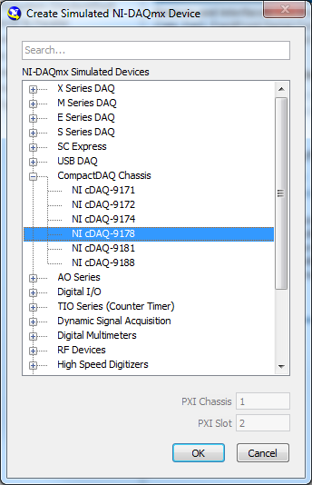

Now the LabVIEW UI will detect the Chassis:

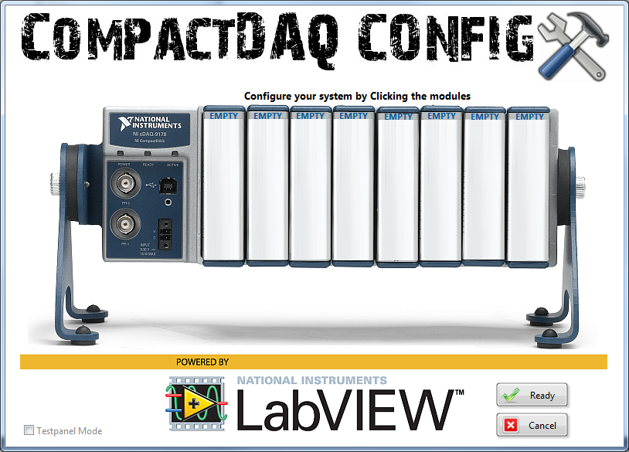

1. **Add modules to the Chassis:**

Right click the Chassis and select “**Configure Simulated cDAQ Chassis…**”

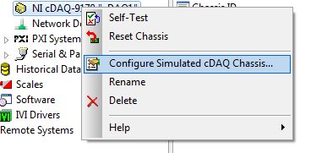

Add these modules:

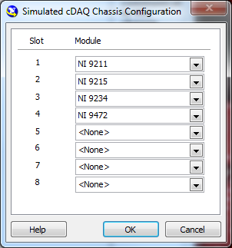

The SW should now discover those modules (you can delete/add modules and it should discover those automatically):

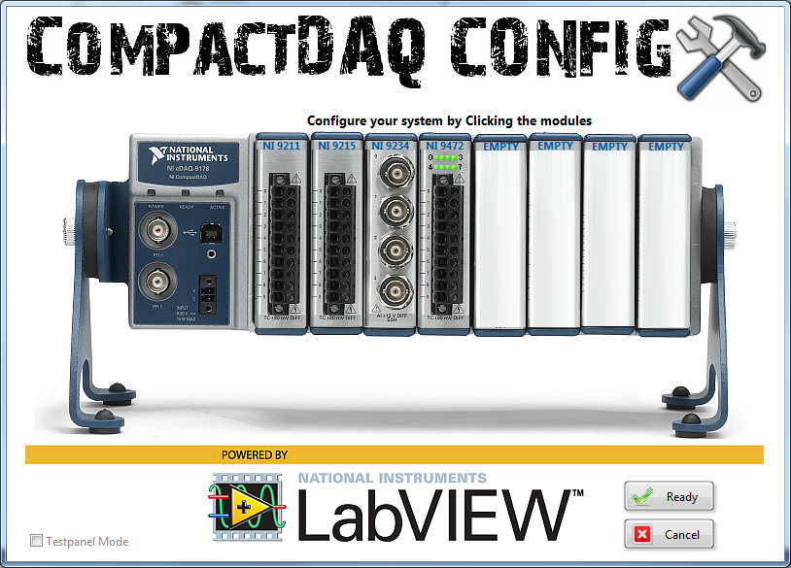

**Mouse Over** those modules and you will see a description of the module:

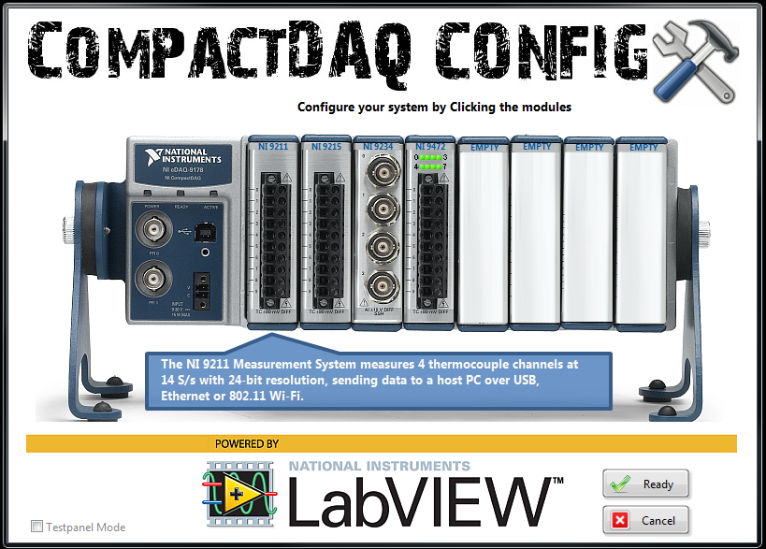

Then select “Testpanel Mode”:

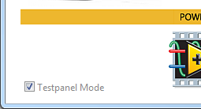

Now click one of those modules and it will open the Test Panel ;) Close the Test Panel…

Uncheck the Testpanel Mode and click the module and it will then open the configuration window. Use the defaults and just select OK (**do it for all of those 4 modules**):

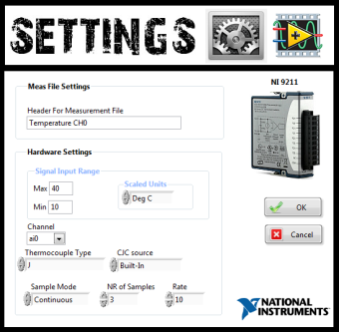 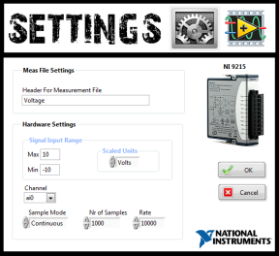 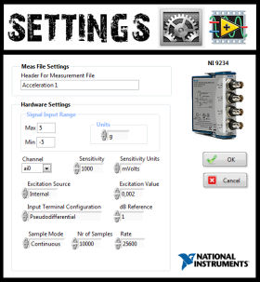 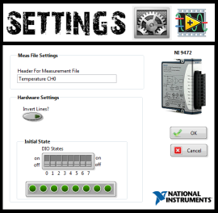

After you have done all four configurations Click the “**Ready**” button:

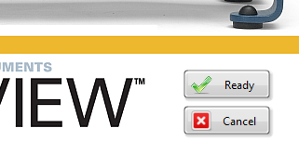

And it will then launch the iPAD screen with measurement VIs running (Scroll Left or Right by using your Right mouse button):

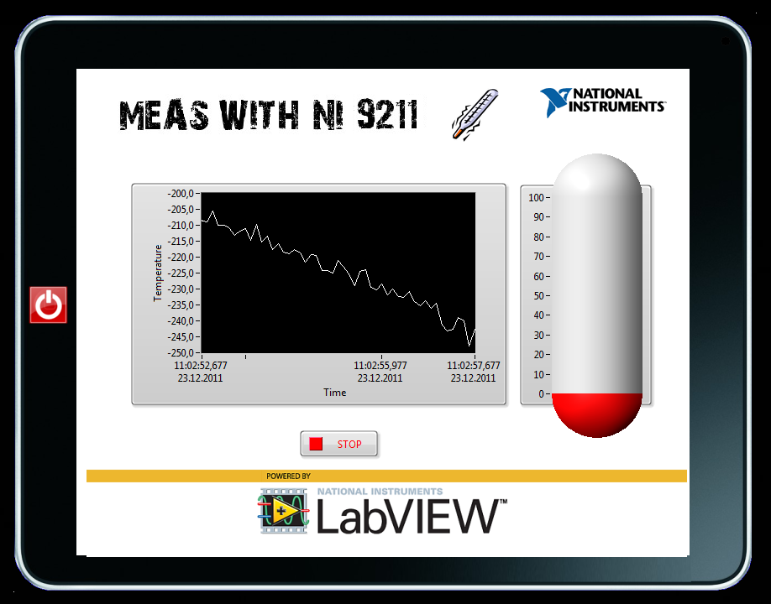

If you now remove for example the first module (or whole system) from the MAX then this will show up:

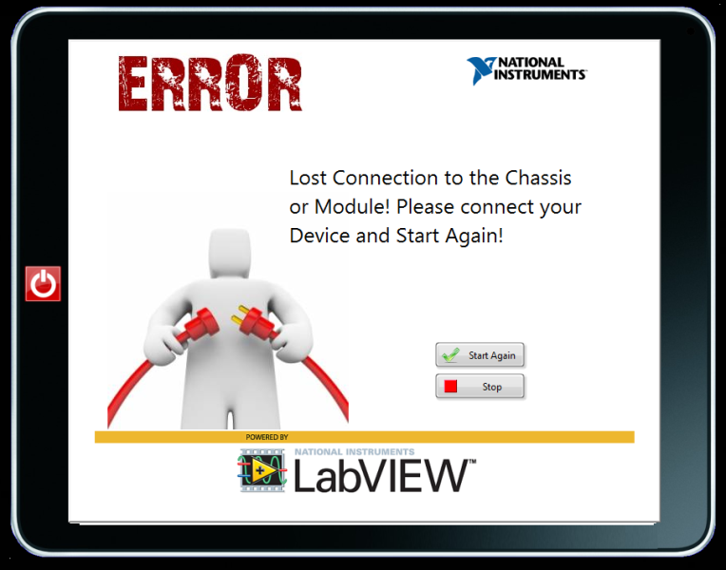

Put the module back and hit the “Start Again” button and the code should continue measurements.

If you this SW in a tradeshow then you can use the hidden feature to automatically change the measurement screen within 5 seconds. Try to find the small hidden “Radio button” from the upper right corner (just click with your left mouse button all over there).



When you find it and click it on it should look like this:



**Can I use it with Real HW too?**

Yeah you can use this code with real HW too ;) But please use with these HW only:

**Chassis types:** **NI cDAQ-9171, NI cDAQ-9172**, **NI cDAQ-9174** or **NI cDAQ-9178**

**Module types: NI 9211**, **NI 9215, NI 9219**, **NI 9234**, **NI 9263** and **NI 9472**.

You may add more modules if you create new settings and measurement VIs here: …\**Dynamic “Loading\Settings”** and …”\**Dynamic Loading\MeasUIs”**

Enjoy!

**Questions?** -> [samuli.bergstrom@ni.com](mailto:samuli.bergstrom@ni.com)

**TODO:**

* Support for NI cDAQ-9181 and NI cDAQ-9188
* Support more Modules
* Better recovery from Error